Here are the options we have for shirts through Gandy. We have 3 options: a cotton shirt, a boy’s polo, and a girl’s polo. Please let me know if you are interested in purchasing one of these. I need to send in predicted quantities to Gandy before ordering these.

- Cotton Shirt option (made by our teammate Presley).
  - This will look slightly different once Gandy sends their version using this mock-up.
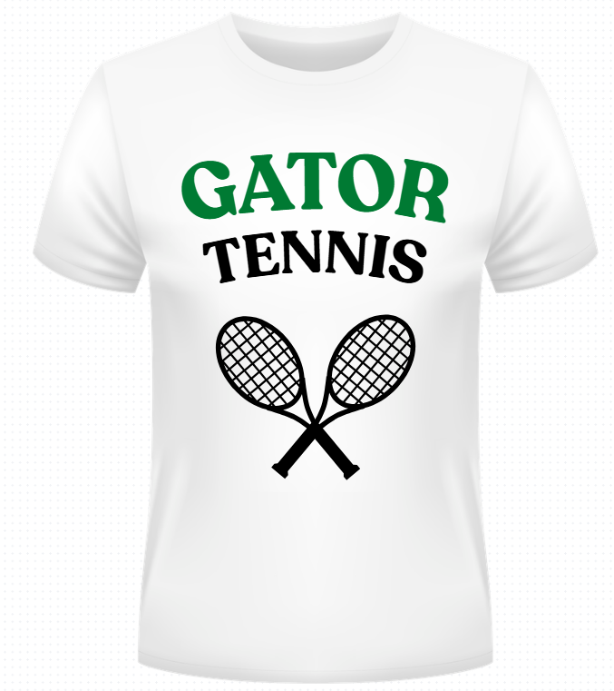

- Boys polo option
  - This is what Gandy sent me after I created the mockup, so it should look just like this.
  - 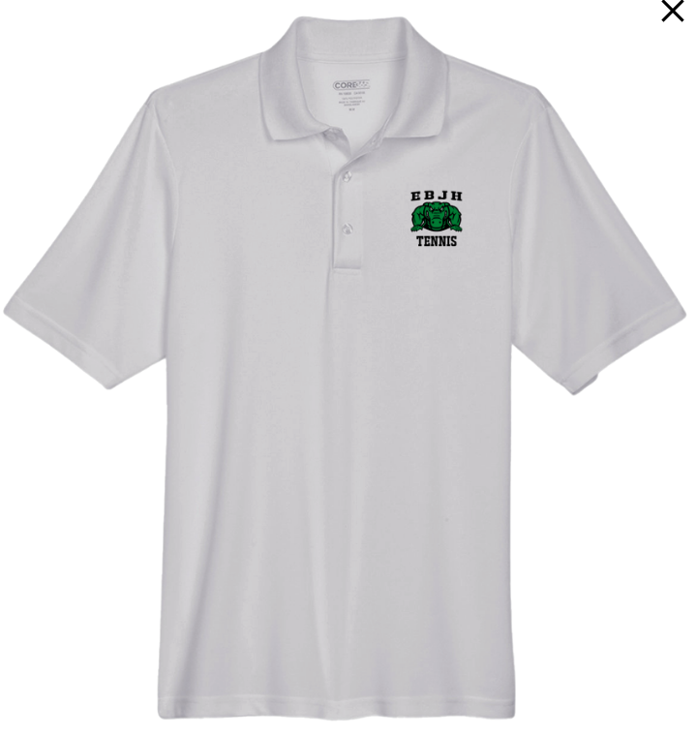

- Girls polo option
  - This is what Gandy sent me after I created the mockup, so it should look just like this.
